JAVA ASSESSEMENT
NAME:S.JAYASHREE
REG NO:192471041
1. Read two numbers and an operator symbol (+, -, *, /, %). Perform0 the selected arithmetic operation using a selection structure and handle division by zero.
FLOWCHART
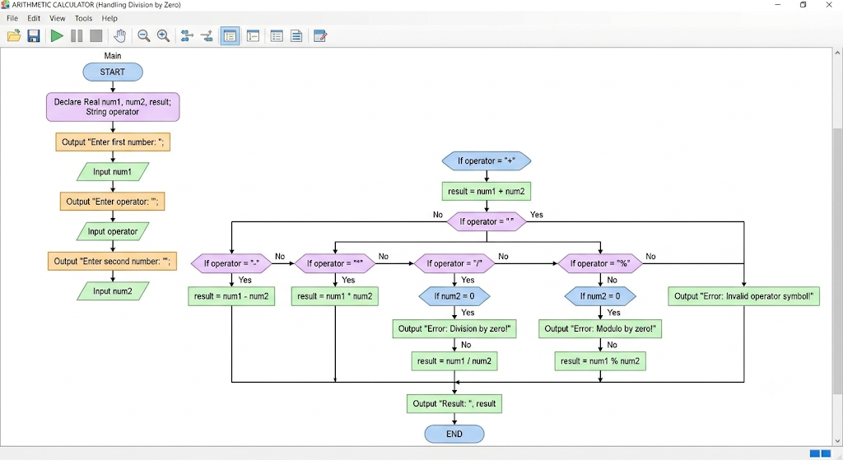
PSEUDOCODE
Function Main
Declare Real num1, num2, result
Declare String operator

Output "Enter first number: "
Input num1
Output "Enter operator (+, -, *, /, %): "
Input operator
Output "Enter second number: "
Input num2

If operator == "+" Then
Set result = num1 + num2
Output "Result: " & result
Else
If operator == "-" Then
Set result = num1 - num2
Output "Result: " & result
Else
If operator == "*" Then
Set result = num1 * num2
Output "Result: " & result
Else
If operator == "/" Then
If num2 == 0 Then
Output "Error: Division by zero!"
Else
Set result = num1 / num2
Output "Result: " & result
End
Else
If operator == "%" Then
If num2 == 0 Then
Output "Error: Modulo by zero!"
Else
Set result = num1 % num2
Output "Result: " & result
End
Else
Output "Error: Invalid operator symbol!"
End
End
End
End
End
End
JAVA PROGRAM
import java.util.Scanner;

public class Main {
public static void main(String[] args) {
Scanner scanner = new Scanner(System.in);

// Declare Real num1, num2, result
// Declare String operator
double num1, num2, result;
String operator;

// Inputs
System.out.print("Enter first number: ");
num1 = scanner.nextDouble();

System.out.print("Enter operator (+, -, *, /, %): ");
operator = scanner.next();

System.out.print("Enter second number: ");
num2 = scanner.nextDouble();

// Selection Logic
if (operator.equals("+")) {
result = num1 + num2;
System.out.println("Result: " + result);
} else {
if (operator.equals("-")) {
result = num1 - num2;
System.out.println("Result: " + result);
} else {
if (operator.equals("*")) {
result = num1 * num2;
System.out.println("Result: " + result);
} else {
if (operator.equals("/")) {
if (num2 == 0) {
System.out.println("Error: Division by zero!");
} else {
result = num1 / num2;
System.out.println("Result: " + result);
}
} else {
if (operator.equals("%")) {
if (num2 == 0) {
System.out.println("Error: Modulo by zero!");
} else {
result = num1 % num2;
System.out.println("Result: " + result);
}
} else {
System.out.println("Error: Invalid operator symbol!");
}
}
}
}
}

scanner.close();
}
}

2. Read a positive integer and calculate the sum of its digits and product of its digits.
FLOWCHART
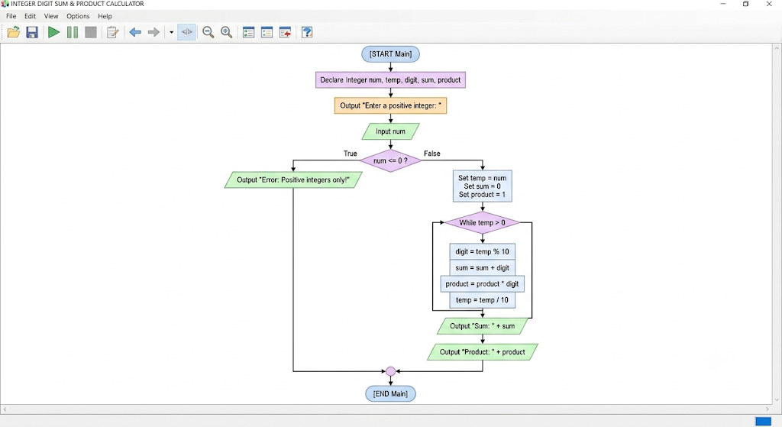
PSEUDOCODE
Function Main
Declare Integer num
Declare Integer temp
Declare Integer digit
Declare Integer sum
Declare Integer product
Output "Enter a positive integer: "
Input num
If num <= 0 Then
Output "Error: Positive integers only!"
Else
Set temp = num
Set sum = 0
Set product = 1
While temp > 0
Set digit = temp % 10
Set sum = sum + digit
Set product = product * digit
Set temp = temp / 10

Output "Sum of digits: " & sum
Output "Product of digits: " & product
End
End
JAVA PROGRAM
import java.util.Scanner;

public class DigitSumAndProduct {
public static void main(String[] args) {
Scanner scanner = new Scanner(System.in);
int num, temp, digit;
int sum = 0;
int product = 1;
System.out.print("Enter a positive integer: ");
num = scanner.nextInt();
if (num <= 0) {
System.out.println("Error: Positive integers only!");
} else {
// Initialization Phase
temp = num;
while (temp > 0) {
digit = temp % 10; // Extract the last digit
sum = sum + digit; // Add digit to sum
product = product * digit; // Multiply digit into product
temp = temp / 10; // Remove the last digit
}
System.out.println("Sum of digits: " + sum);
System.out.println("Product of digits: " + product);
}

scanner.close();
}
}

3. Design a shape-calculation flowchart in which Circle, Rectangle, and Square follow a common area operation. Explain how a Java interface named Shape could define area().
FLOWCHART
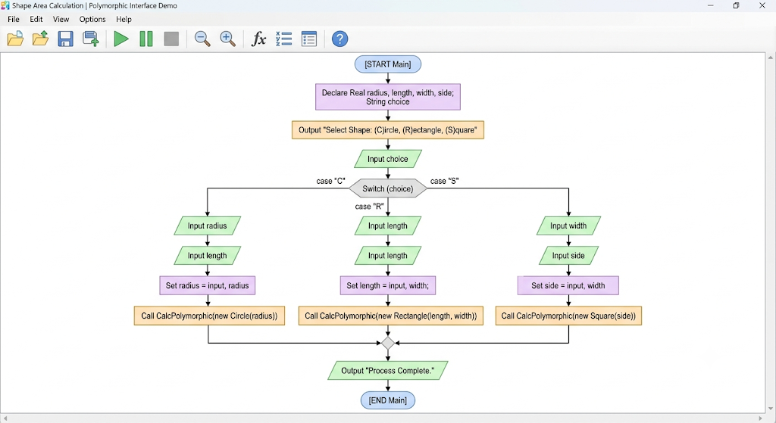
PSEUDOCODE
Interface Shape
Function area() Returns Real
End Interface

Function Main
Declare Real radius, length, width, side
Declare String choice
Declare Shape shapeObj

Output "Select Shape: (C)ircle, (R)ectangle, (S)quare"
Input choice

Switch choice
Case "C", "c":
Output "Enter Circle radius: "
Input radius
Set shapeObj = New Circle(radius)
Call CalculateAreaPolymorphic(shapeObj)

Case "R", "r":
Output "Enter Rectangle length: "
Input length
Output "Enter Rectangle width: "
Input width
Set shapeObj = New Rectangle(length, width)
Call CalculateAreaPolymorphic(shapeObj)

Case "S", "s":
Output "Enter Square side: "
Input side
Set shapeObj = New Square(side)
Call CalculateAreaPolymorphic(shapeObj)

Default:
Output "Error: Invalid shape selection!"
End Switch

Output "Process Complete."
End Function
JAVA PROGRAM
import java.util.Scanner;

interface Shape {
double area();
}

class Circle implements Shape {
private double radius;

public Circle(double radius) {
this.radius = radius;
}

@Override
public double area() {
return Math.PI * radius * radius;
}
}

class Rectangle implements Shape {
private double length;
private double width;

public Rectangle(double length, double width) {
this.length = length;
this.width = width;
}

@Override
public double area() {
return length * width;
}
}

class Square implements Shape {
private double side;

public Square(double side) {
this.side = side;
}

@Override
public double area() {
return side * side;
}
}

public class ShapeAreaCalculator {

public static void printArea(Shape shapeObj) {
double result = shapeObj.area();
System.out.printf("Calculated Area: %.2f%n", result);
}

public static void main(String[] args) {
Scanner scanner = new Scanner(System.in);

System.out.println("Select Shape: (C)ircle, (R)ectangle, (S)quare");
System.out.print("Enter choice: ");
String choice = scanner.next().toUpperCase();

Shape shapeObj = null;

switch (choice) {
case "C":
System.out.print("Enter Circle radius: ");
double radius = scanner.nextDouble();
shapeObj = new Circle(radius);
break;

case "R":
System.out.print("Enter Rectangle length: ");
double length = scanner.nextDouble();
System.out.print("Enter Rectangle width: ");
double width = scanner.nextDouble();
shapeObj = new Rectangle(length, width);
break;

case "S":
System.out.print("Enter Square side: ");
double side = scanner.nextDouble();
shapeObj = new Square(side);
break;

default:
System.out.println("Error: Invalid shape selection!");
break;
}

if (shapeObj != null) {
printArea(shapeObj);
}

System.out.println("Process Complete.");
scanner.close();
}
}

